Next Smaller Element
Problem Statement: Given an array of integers arr, your task is to find the Next Smaller Element (NSE) for every element in the array.
The Next Smaller Element for an element x is defined as the first element to the right of x that is smaller than x.
If there is no smaller element to the right, then the NSE is -1.
Example 1:
Input: arr = [4, 8, 5, 2, 25]
Output: [2, 5, 2, -1, -1]
Explanation:
- For 4, the next smaller element is 2.
- For 8, the next smaller element is 5.
- For 5, the next smaller element is 2.
- For 2, there is no smaller element to its right → -1.
- For 25, no smaller element exists → -1.
Algorithm
- Initialize an answer array filled with -1
- Initialize an empty stack
- Loop from i = n - 1 to 0
- While stack is not empty and top is greater than or equal to current element, pop the stack
- If stack is not empty, set answer[i] to top of stack
- Push current element to stack
- Return the answer array
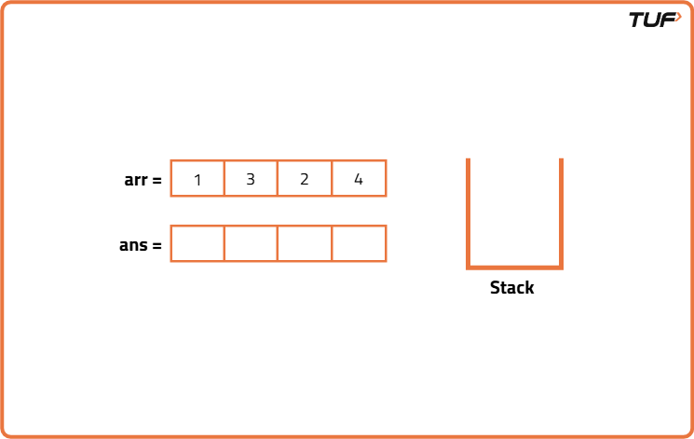

class Solution {

// Function to find next smaller element using stack
public int[] nextSmallerElement(int[] arr) {
int n = arr.length;

// Stack to keep potential next smaller elements
Stack<Integer> st = new Stack<>();

// Initialize result array with -1
int[] ans = new int[n];
Arrays.fill(ans, -1);

// Traverse from right to left
for (int i = n - 1; i >= 0; i--) {

// Pop elements from stack that are not smaller
while (!st.isEmpty() && st.peek() >= arr[i]) {
st.pop();
}
// If stack not empty, top is the next smaller element
if (!st.isEmpty()) {
ans[i] = st.peek();
}
// Push current element to stack
st.push(arr[i]);
}
// Return result
return ans;
}
}

